
Kingdom of Bahrain
Primary Healthcare Centers

Naraak

Phase 1: Review Current e-Services and Identify Pain Points

Prepared by
Fatima Yaser Darraj
Eman Yaser Alasaadi
Alya Hasan Aldaka
IT Trainees

Submitted to
Mohamed Ateya Neama
Fatema Isa Nooh

6 August 2026

Table of Contents
Table of Contents 2
Table of Figures 4
1. Document Control 5
1.1 Version History 5
1.2 Approval / Sign-off 5
2. Executive Summary 6
3. Review Current PHC e-Services 7
3.1 Introduction 7
3.2 Methodology 7
3.3 Usability / Heuristic Review 7
3.3.1 Services Review 8
3.3.1.1 Sehati Application 8
3.3.1.1.1 Appointment Booking Service 8
3.3.1.1.2 Medical Reports & Certificates Service 9
3.3.1.1.3 Vaccination Record Service 10
3.3.1.2 MyGov Application 10
3.3.1.2.1 Vaccination Record Service 11
3.3.1.2.2 Report Missing Vaccination Record Service 12
3.3.1.3 Ministry of Health (MOH) website 12
3.3.1.3.1 Sehati Card Request for Newborns Service 13
3.3.1.3.2 Update Residential Address Service 13
3.3.1.3.3 Mammogram Appointment Request Service 14
3.3.1.3.4 Tele Appointment Instructions Service 15
3.3.1.3.5 Vaccine Certificate Service 15
3.3.1.3.6 Health Fee Exemption Card Issuance Service 16
3.3.1.3.7 Request to Change Your Family Doctor Service 16
3.3.1.3.8 Electronic Hajj Certificate Service 16
3.3.1.3.9 Request Mobile Unit Service 17
3.3.1.3.10 Primary Healthcare Research Applications Service 17
3.4 Stakeholder & End-User Engagement 18
3.5 Findings by Service 22
3.5.1 Booking Appointments 22
3.5.2 Vaccination Records & Certificate 23
3.5.3 Medical Reports & Certificates 24
3.5.4 Electronic Hajj Certificate 25
3.5.5 Tele-Appointment Instructions 26
3.5.6 Sehati Card Request for Newborns 26
3.5.7 Update Residential Address 27
3.5.8 Health Fee Exemption Card Issuance 28
3.5.9 Request Mobile Unit Service 28
3.5.10 Mammogram Appointment Requests 29
3.5.11 Change Family Doctor 29
3.5.12 Primary Healthcare Research Applications 30
4. Cross-Cutting / Non-Functional Findings 32
4.1 Performance 32
4.2 Availability & Reliability 32
4.3 Accessibility 33
4.4 Localization 34
4.5 Security & Privacy Perception 34
4.6 Platform-Level Features 35
4.7 Non-Functional Requirements Not Surfaced in Phase 1 35
5. Prioritized Pain Point Summary 35
6. Product Requirements 36
7. Recommendations 37
References 39
Appendix A: Stakeholder Survey (Questionnaire-1) 40
Appendix B: Patient/End-user Survey (Questionnaire-2) 45

Table of Figures

Figure 1: Sehati Application 8
Figure 2: Appointment Booking Service 9
Figure 3: Medical Reports & Certificates Service 9
Figure 4: Vaccination Record Service 10
Figure 5: MyGov Application 10
Figure 6: PHC Services in MyGov Application 11
Figure 7: Vaccination Record Service 11
Figure 8: Report Missing Vaccination Record Service 12
Figure 9: PHC Services in Ministry of Health website 13
Figure 10: Sehati Card Request for Newborns Service 13
Figure 11: Update Residential Address Service 14
Figure 12: Mammogram Appointment Request Service 14
Figure 13: Tele Appointment Instructions Service 15
Figure 14: Vaccine Certificate Service 15
Figure 15: Health Fee Exemption Card Issuance Service 16
Figure 16: Request to Change Your Family Doctor Service 16
Figure 17: Electronic Hajj Certificate Service 17
Figure 18: Request Mobile Unit Service 17
Figure 19: Primary Healthcare Research Applications Service 18
Figure 20: Bahrain Population (Worldometer, 2026) 18
Figure 21: Sample Size Calculation for the End-User Survey 19
Figure 22: Distribution of Stakeholder Survey Participants by Role 20
Figure 23: Demographic Distribution of Patient Survey Participants (Age Group, Gender, and Nationality) 21
Figure 24: Service usage vs. problem-flagging rate — patient survey (n=74). 22
Figure 25: Platform ratings: ease of finding & completing services (patients) vs. performance/speed (stakeholders). 32
Figure 26: Error/outage frequency by platform — patient survey (n=74). 33
Figure 27: Requested accessibility features — patients vs. stakeholders. 34
Figure 28: Preferred display layout for PHC services — patient survey (n=74). 34

Document Control

Version History
Version | Date | Author | Change Description
0.1 | 25 July 2026 | IT Trainee Team | Document Template, basic information
0.2 | 26 July 2026 | IT Trainee Team | Platforms Review, resolute of the review
0.3 | 30 July 2026 | IT Trainee Team | Stakeholders Questions
0.4 | 1 August 2026 | IT Trainee Team | End Users Questions
0.5 | 2 August 2026 | IT Trainee Team | Stakeholders Questionary resolute
0.6 | 4 August 2026 | IT Trainee Team | End Users Questionary resolute
0.7 | 6 August 2026 | IT Trainee Team | Demographic Analysis and References Added

Approval / Sign-off

Role | Name | Signature | Date
Project Supervisor | Mohamed Ateya Neama
Project Supervisor | Fatema Isa Nooh
PHC/MOH Stakeholder | Mohamed Khalil

Executive Summary

This report documents Phase 1 of the Naraak project: a systematic review of the existing Sehati application, MyGov application, and MOH website, combined with stakeholder interviews (14 respondents) and a patient/end-user survey (74 respondents) for a total sample size of 89 respondents, which, against a population of 1,684,098 achieves a margin of error of 6.8% at an 80% confidence level, to identify usability pain points and gather functional and non-functional requirements for a dedicated Primary Healthcare Centers e-services platform. The research reveals that PHC e-services are fragmented across three platforms, with patients, especially elderly users struggling to distinguish primary-care services from general hospital offerings. Booking appointments is the most used service (91% of patients) and simultaneously the most problematic (65% flagged it as causing problems), primarily due to limited availability, a rigid doctor-first flow, and system unreliability. Medical reports (38% prioritized), tele-appointments (30% prioritized), and vaccination records (24% prioritized) follow as secondary improvement areas. Platform-wide, patients rated ease of finding and completing PHC services at 3.0/5 on the MOH website, 3.3/5 on MyGov, and 3.5/5 on Sehati indicating that even the best-performing platform barely exceeds neutral. Stakeholders rated performance/speed at Sehati 4.0/5, MyGov 3.5/5, and MOH website 3.4/5. Error and outage frequency averaged 3.1/5 across all platforms (where 5 = rarely encounters errors), confirming regular reliability issues. Stakeholders identified ease of use (64%) and system integration (64%) as the top non-functional priorities, followed by accessibility (43%). These findings directly inform Phase 2 (persona definition, journey mapping, and service prioritization) and will anchor the Software Requirements Specification. The prioritized pain point summary in Section 7 serves as the primary reference for design decisions going forward.

Review Current PHC e-Services

3.1 Introduction
Primary Healthcare Centers (PHCs) are the first point of contact between patients and Bahrain's healthcare system, covering services such as appointment booking, vaccinations, medical reports, and family doctor assignment. These services are currently split across three separate channels the Sehati application, MyGov, and the MOH website each built independently, resulting in inconsistent coverage and a confusing experience for patients, particularly the elderly. Naraak is proposed as a single, dedicated e-services platform to consolidate these fragmented services into one coherent, user-friendly experience. Before any design work begins, Phase 1 of the project establishes a clear picture of the current landscape through three research strands: a heuristic review of the existing platforms, interviews with 14 PHC staff and stakeholders, and a survey of 74 patients. Together, these identify what is broken, how often, and how severely findings are presented by service in Section 5, summarized cross-cutting in Section 6, and prioritized in Section 7. This phase is diagnostic rather than prescriptive: its purpose is to ground Phase 2 (personas, journey mapping, and service prioritization) and the eventual Software Requirements Specification in real evidence rather than assumptions.

3.2 Methodology
This section summarizes execution status against the original research plan, covering the heuristic review (3.3) and stakeholder/end-user engagement (3.4).
- Heuristic Review: An independent walkthrough of Sehati, MyGov, and the MOH website was conducted by the project team across all three platforms on 26 July 2026, documenting friction points, inconsistencies, and legacy interface limitations ahead of stakeholder engagement.
- Stakeholder & End-User Engagement: Semi-structured interviews and a quantitative survey were used in combination.

3.3 Usability / Heuristic Review
An independent walkthrough of Sehati, MyGov, and the MOH website was conducted by the project team, documenting friction points, inconsistencies, and legacy interface limitations ahead of stakeholder engagement.

Channel | Reviewed By | Date(s) | Devices / OS Covered | Notes
Sehati Application | Alya Hasan Aldaka | 26/7/2026 | IOS/Android
MyGov Application | Fatima Yaser Darraj | 26/7/2026 | IOS/Android | Only two services found
MOH Website | Eman Yaser AlAsaadi | 26/7/2026 | Windows 11/Android /IOS | There is no ease in finding the service from the phone screen on more than one different device.

3.3.1 Services Review
This section reviews the existing Primary Healthcare Centers (PHC) e-services currently available through the Sehati application, MyGov application and Ministry of Health (MOH) website. Each service is evaluated to understand its current workflow, identify usability issues, and assess how effectively it supports users in completing common PHC tasks. The findings from this review provide the foundation for identifying improvement opportunities and guiding the redesign of the proposed Naraak platform.

3.3.1.1 Sehati Application

The Sehati application is one of the Kingdom of Bahrain's official digital healthcare platforms, providing citizens and residents with access to a range of primary healthcare services (As shown in Figure 1). In addition to general healthcare and hospital services, the application includes several Primary Healthcare Centers (PHC) e-services, including appointment booking, medical records and certificates, and vaccination records and certificates. These services enable users to access essential PHC information and perform routine healthcare tasks through a single mobile application. The following subsections review each PHC service to evaluate its current user experience, identify usability issues, and highlight opportunities for improvement.
Figure 1: Sehati Application

3.3.1.1.1 Appointment Booking Service
The appointment booking flow was reviewed by walking through the process end-to-end within the Sehati application, from the initial "Upcoming Appointments" screen to time-slot selection (as shown in Figure 2). The booking process requires users to complete a lengthy sequence of steps before an appointment can be confirmed. Users must select a health center, a specialty (e.g., Dental or General Clinic), a doctor, a date, and finally a time slot from a list of available options. Each step must be completed in sequence, and the flow does not allow users to skip ahead. For a time-sensitive task such as booking a medical appointment, this multi-step, doctor-centric process increases the time and effort required, particularly for users who simply want the earliest available appointment rather than a specific doctor. The "Upcoming Appointments" landing screen adds a further layer of confusion by displaying booking cards for Health Center, King Hamad University Hospital, Government Hospitals, and SMC Medical Prescriptions Delivery Service side by side, without any clear visual or textual distinction between Primary Healthcare Centers services and general hospital or prescription delivery services. As a result, users particularly older adults and those with limited digital literacy may struggle to identify the correct PHC service, increasing the likelihood of selecting the wrong category before the booking process even begins.

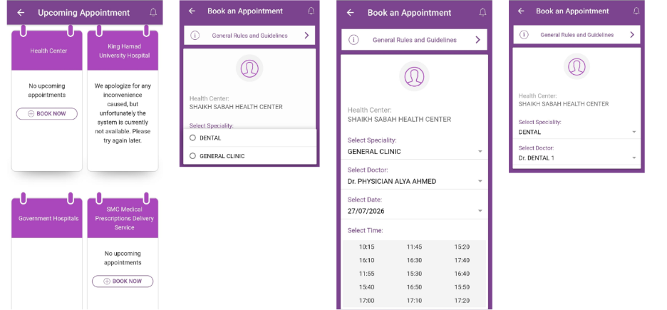
Figure 2: Appointment Booking Service

3.3.1.1.2 Medical Reports & Certificates Service
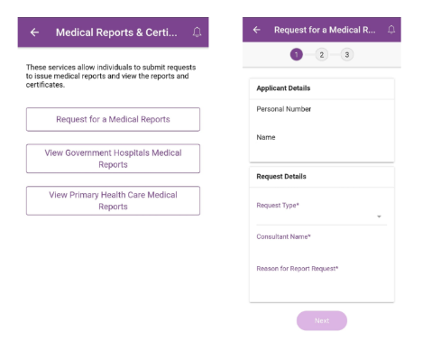
The service is generally straightforward and easy to use (See Figure 3). Users can request medical reports and access Primary Healthcare medical reports through a simple interface. However, when requesting a medical report, users are required to manually enter the consultant's name as free text. Since many patients may not remember the consultant's exact name or spelling, this increases the likelihood of errors and unsuccessful requests.
Figure 3: Medical Reports & Certificates Service

3.3.1.1.3 Vaccination Record Service
The vaccination record service allows users to view their vaccination history and download vaccination certificates (See Figure 4). During the heuristic review, the service experienced system availability issues, preventing some functions from loading correctly. In addition, uploading supporting documents was not always successful because the system provided limited guidance regarding supported file formats and maximum file sizes. These issues may prevent users from completing their requests successfully and create unnecessary confusion.
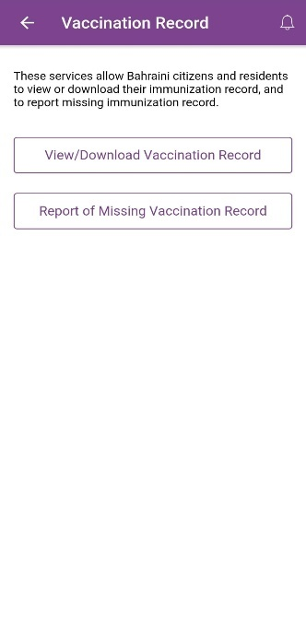
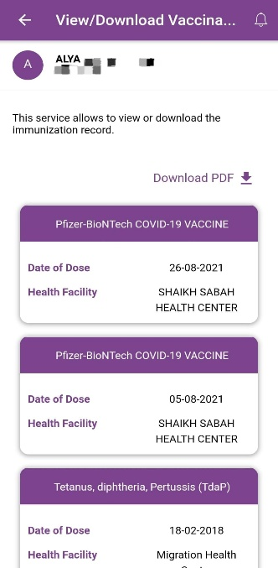
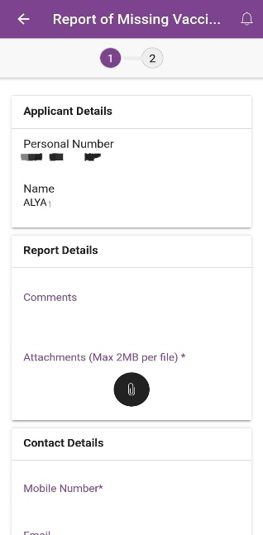

Figure 4: Vaccination Record Service

3.3.1.2 MyGov Application

MyGov is the Kingdom of Bahrain's centralized government services application (See Figure 5), designed to provide citizens and residents with access to a wide range of digital services from various government entities through a single platform. Instead of using separate applications for each ministry or government organization, users can access services from multiple sectors including healthcare, education, transportation, municipalities, identity services, and other public services from one unified application. This centralized approach simplifies access to government e-services and improves the overall user experience.
Figure 5: MyGov Application

Within the Primary Health Care (PHC) category, the application currently provides two vaccination-related services (As shown in Figure 6). During the evaluation, both services functioned correctly, with no significant usability issues identified. The interface is clean, easy to navigate, and the workflows are straightforward.
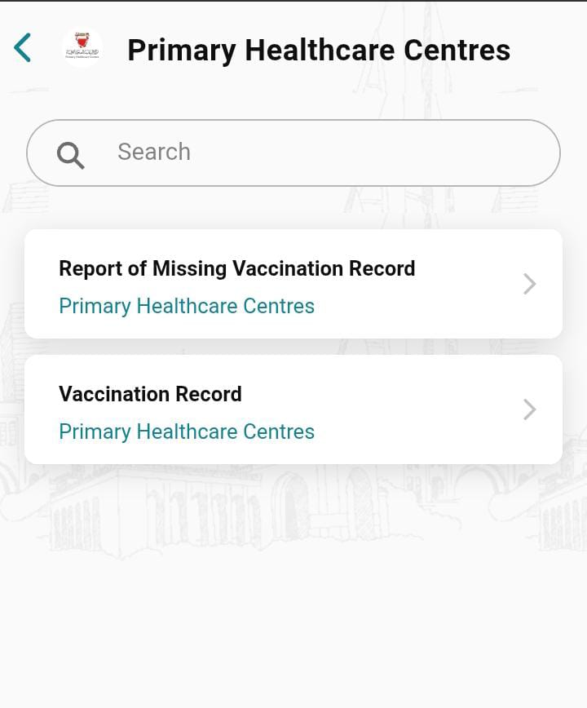
Figure 6: PHC Services in MyGov Application

        - Vaccination Record Service
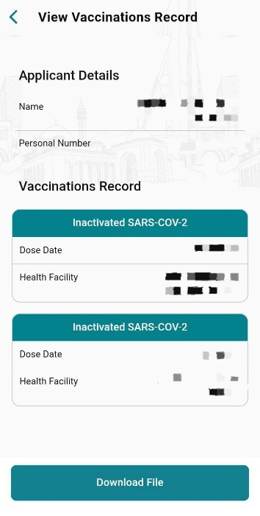
This service allows users to view their complete vaccination history. Each vaccination entry displays relevant information such as the vaccine name, vaccination date, and the health center where the vaccine was administered. Users can also download their vaccination record for personal use or official purposes (See Figure 7).
Figure 7: Vaccination Record Service

        - Report Missing Vaccination Record Service
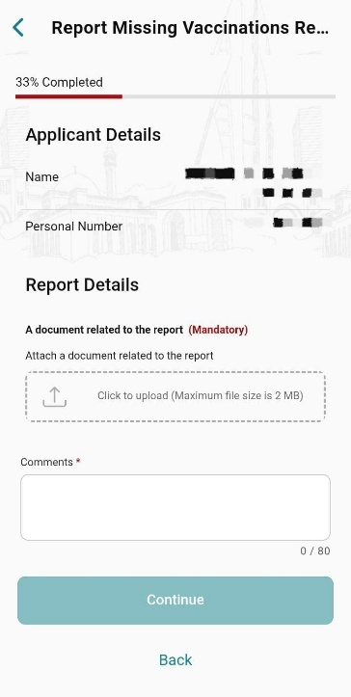
This service enables users to report vaccinations that are missing from their official vaccination record. Users enter their personal information, upload supporting documents, provide any necessary notes, and submit the request for review by the relevant authority (As shown in Figure 8).
Figure 8: Report Missing Vaccination Record Service

However, the most noticeable limitation of the MyGov application is that it currently offers only two Primary Health Care services, both of which are related to vaccinations. Although these services are implemented effectively, the limited number of PHC services reduces the application's usefulness for users seeking broader healthcare services. Expanding the range of PHC services available within MyGov would enhance its value and reduce the need for users to rely on other government platforms.

Ministry of Health (MOH) website
The Ministry of Health (MOH) website is the official digital platform for healthcare services in the Kingdom of Bahrain (see Figure 9). The website provides a wide range of healthcare-related information and online services organized into multiple categories. One of these categories is Primary HealthCare Centers (PHC) e-Services, which offers various digital services for citizens and residents. To access these services, users are required to log in by providing their CPR number, Block Number, and CPR Expiry Date for identity verification. After successful authentication, users can submit service requests, update personal health information, obtain official certificates, and access a variety of administrative and preventive healthcare services without visiting a health center. However, when we tried accessing the site through a standard search on various mobile phones, we couldn't find the services as easily as on computers, without any explanation to the user. Unfortunately, this means most users cannot benefit from the services if they search for them directly from their phones.

Overall, the website offers a broad collection of PHC e-services that support different healthcare needs. During the evaluation, all services functioned correctly and no significant usability problems were identified. The services are organized into dedicated pages with consistent layouts, clear instructions, and standardized request forms.
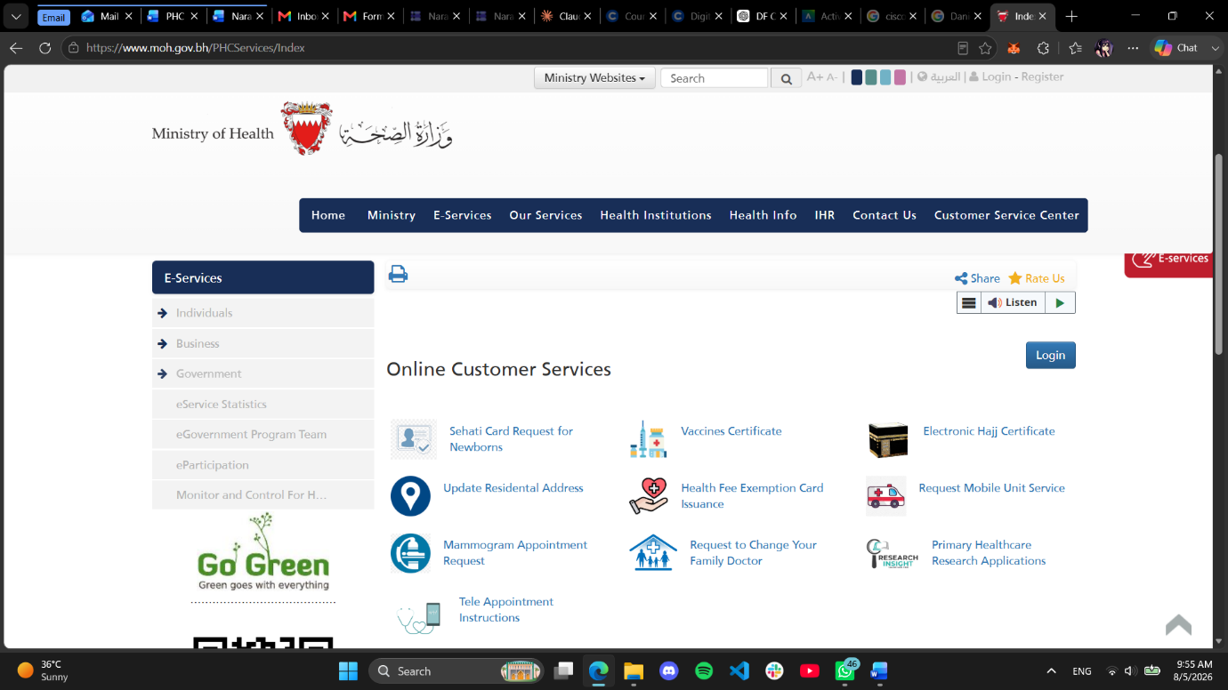
Figure 9: PHC Services in Ministry of Health website

Sehati Card Request for Newborns Service
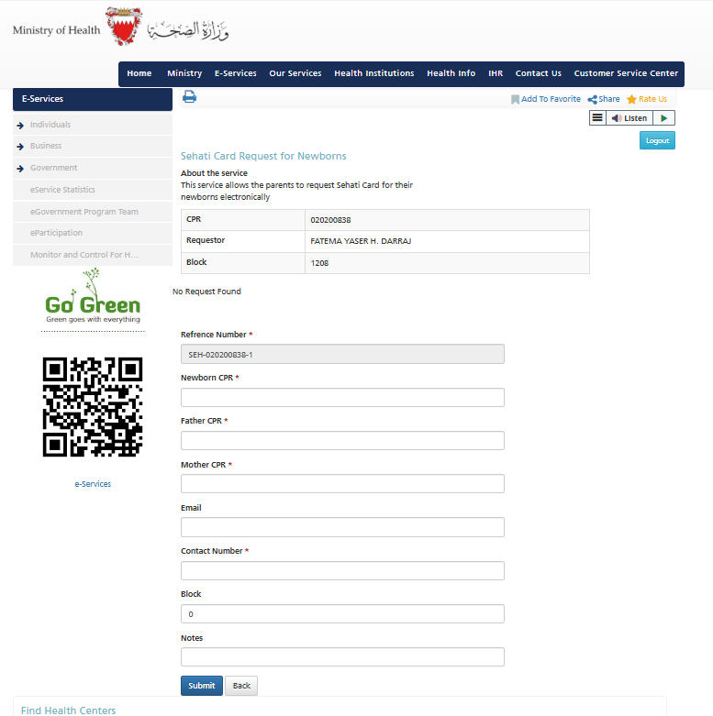
This service allows parents to electronically request a Sehati Card for their newborn child. The request form collects the newborn's CPR, parents' CPR numbers, contact information, residential block, and optional notes before submitting the request.
Figure 10: Sehati Card Request for Newborns Service

3.3.1.3.2 Update Residential Address Service
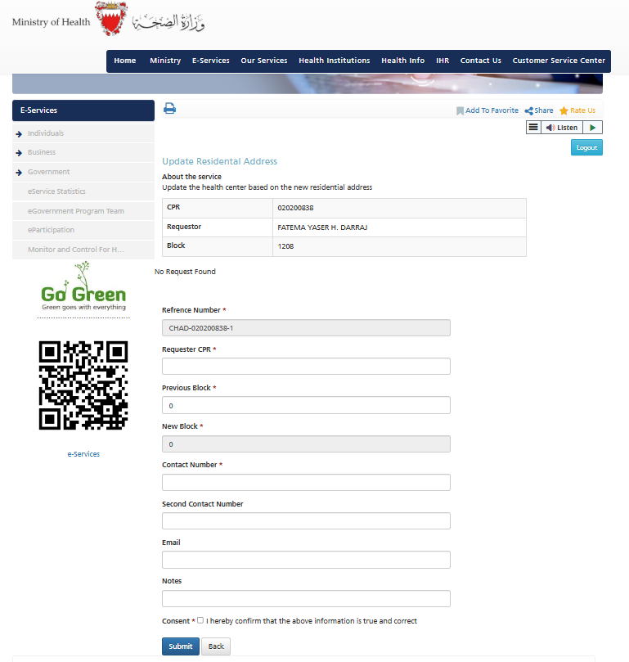
This service enables users to update their residential address so that their assigned Primary Health Care center is changed according to their new place of residence. Users provide their CPR, previous and new residential block information and contact details before submitting the request.
Figure 11: Update Residential Address Service

Mammogram Appointment Request Service
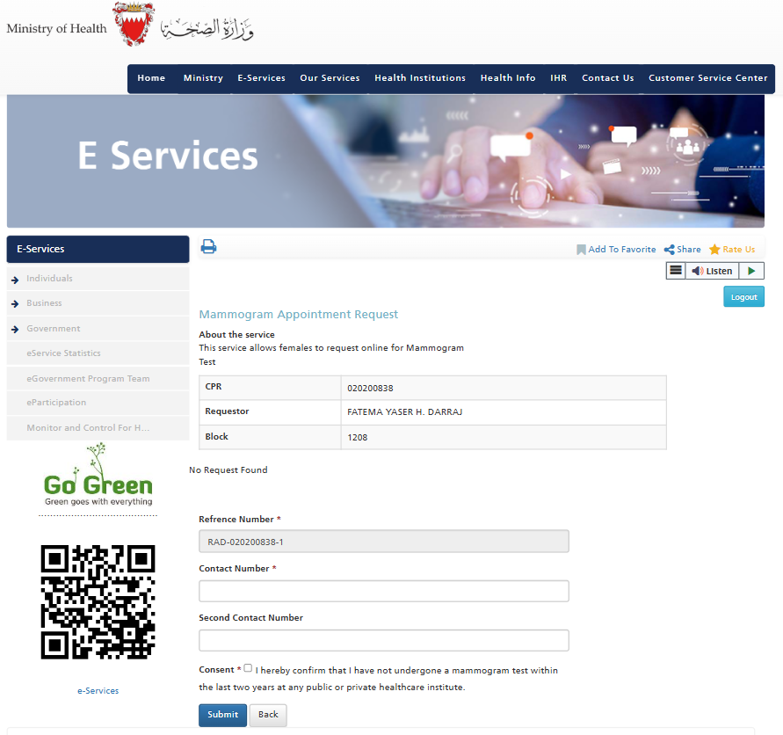
This service allows eligible female patients to request a mammogram appointment online. Users provide their contact information and confirm that they have not undergone a mammogram examination within the previous two years before submitting the request
Figure 12: Mammogram Appointment Request Service

3.3.1.3.4 Tele Appointment Instructions Service
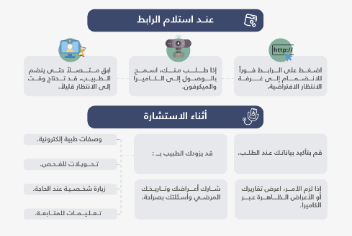
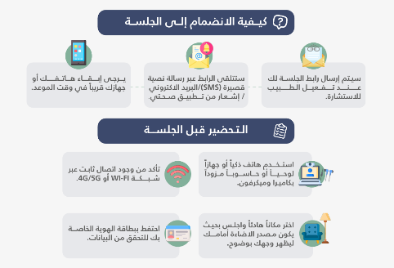

Rather than being an interactive service, this page provides general guidance for patients participating in virtual medical consultations. It explains how appointment links are delivered (via SMS, email, or the Sehati application), the technical requirements before joining the consultation, privacy and confidentiality guidelines, recommended behavior during the session, and instructions to follow after the consultation. However, the page does not clearly explain how users can initiate or request a tele-appointment, as it does not provide a direct method to start the service, such as a request option, contact number, or clear pathway for booking a virtual consultation. As a result, users may need to search for additional information or contact the health center through other channels to begin the process (See Figure 13).
Figure 13: Tele Appointment Instructions Service

3.3.1.3.5 Vaccine Certificate Service
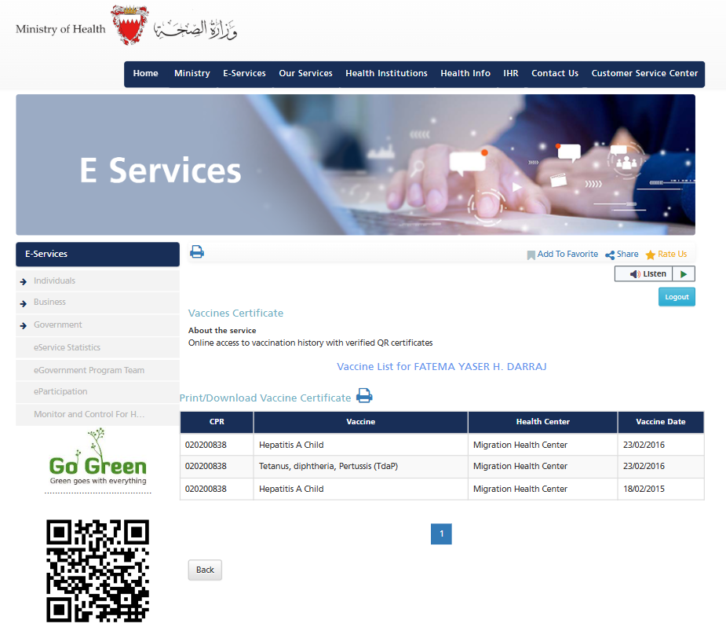
This service provides users with online access to their complete vaccination history and allows them to generate and download an official vaccination certificate containing a verified QR code. The certificate can be printed or downloaded for official use.
Figure 14: Vaccine Certificate Service

3.3.1.3.6 Health Fee Exemption Card Issuance Service
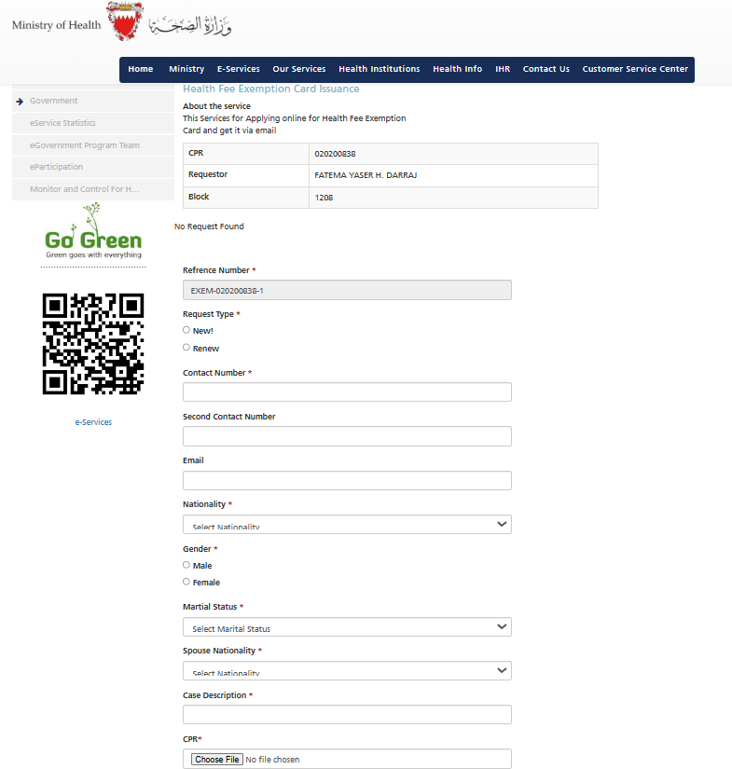
This service allows eligible users to apply for a new Health Fee Exemption Card or renew an existing one. Applicants complete personal information, upload the required supporting documents (such as CPR, residence permit, medical reports, and other applicable documents), and submit the application electronically.
Figure 15: Health Fee Exemption Card Issuance Service

3.3.1.3.7 Request to Change Your Family Doctor Service
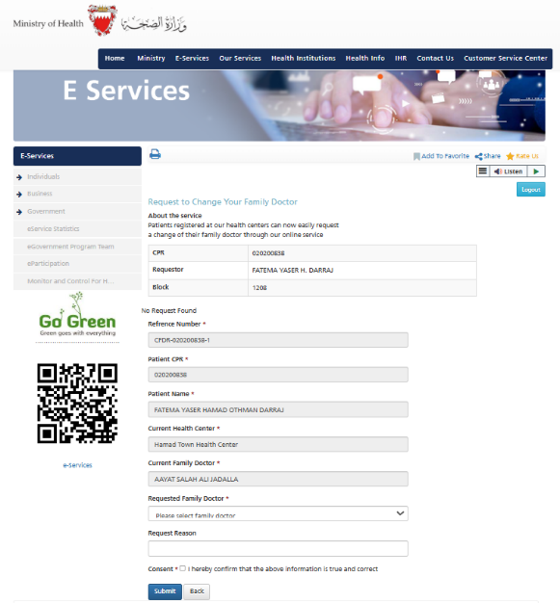
Registered patients can request to change their assigned family doctor without visiting the health center. The form automatically displays the patient's current information and allows the user to select the preferred doctor and provide the reason for the request.
Figure 16: Request to Change Your Family Doctor Service

3.3.1.3.8 Electronic Hajj Certificate Service
This service enables users to obtain an official electronic Hajj vaccination certificate with QR code verification for travel and official purposes. However, the service description does not clearly explain the required steps to obtain the certificate, particularly whether the request must first be initiated by a doctor. Additionally, the page does not specify the service availability period and only displays a “Not Found” message when unavailable, without clarifying whether the service is temporarily unavailable or not activated. This may cause confusion for users attempting to access the service.
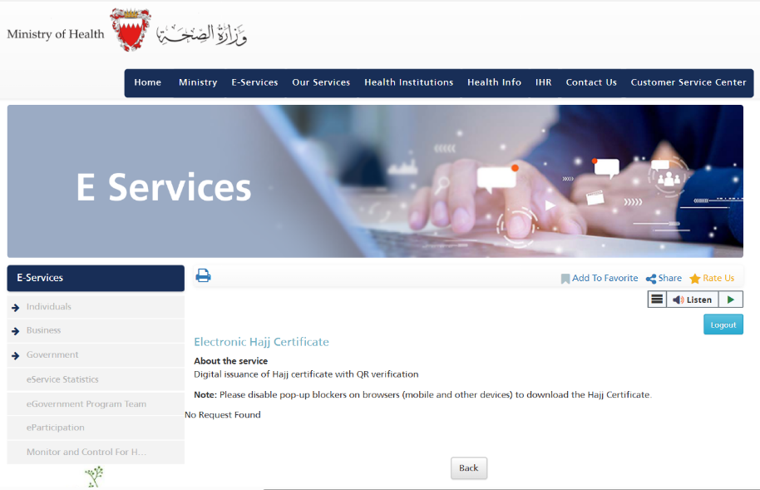
Figure 17: Electronic Hajj Certificate Service

3.3.1.3.9 Request Mobile Unit Service
This service allows elderly patients and people with disabilities to request home healthcare visits. Users provide the patient's information, address, contact details, and the reason for requesting the home visit.

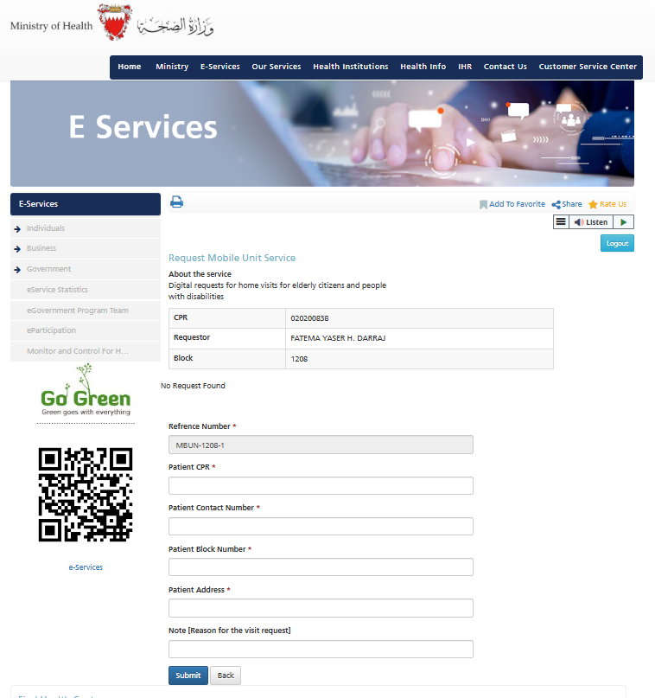

Figure 18: Request Mobile Unit Service

3.3.1.3.10 Primary Healthcare Research Applications Service
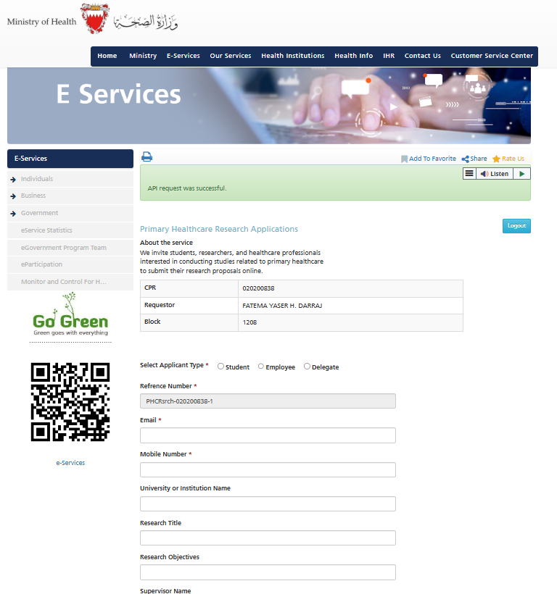
This service enables students, researchers, and healthcare professionals to submit research applications related to Primary Health Care. Applicants provide research details, supervisor information, expected research duration, and upload all required supporting documents electronically.

Figure 19: Primary Healthcare Research Applications Service

3.4 Stakeholder & End-User Engagement
Stakeholder and end-user engagement was conducted through quantitative surveys. Two versions of the survey were developed: one for project stakeholders, including PHC staff and project supervisors, and another for patients and end users. Each questionnaire was tailored to the participants' roles while addressing the study objectives. The surveys were designed to identify user needs, challenges, expectations, and usability issues related to the existing Primary Health Care (PHC) digital services.
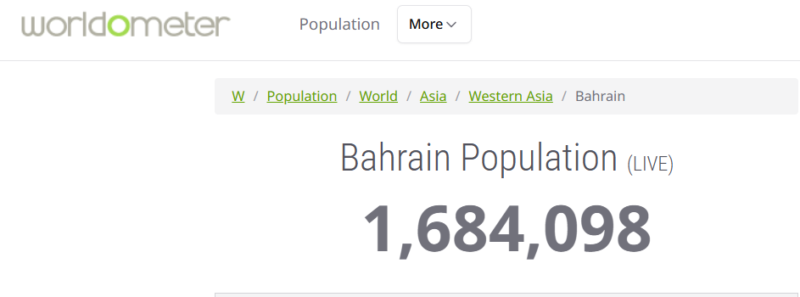
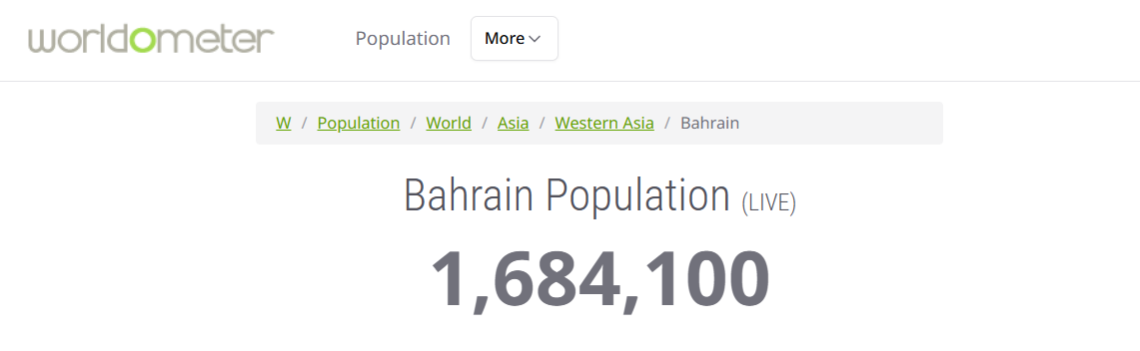


Figure 20: Bahrain Population (Worldometer, 2026)

For the end-user survey, the required sample size was calculated using the SurveyMonkey Sample Size Calculator (SurveyMonkey, n.d.). Based on Bahrain's estimated population of 1,684,098 (Worldometer, 2026; See Figure 20), a minimum sample size of 89 participants was calculated using an 80% confidence level and a 6.8% margin of error (As shown in Figure 21). This sample size was considered sufficient to provide representative insights for the study while remaining feasible within the project's timeframe.
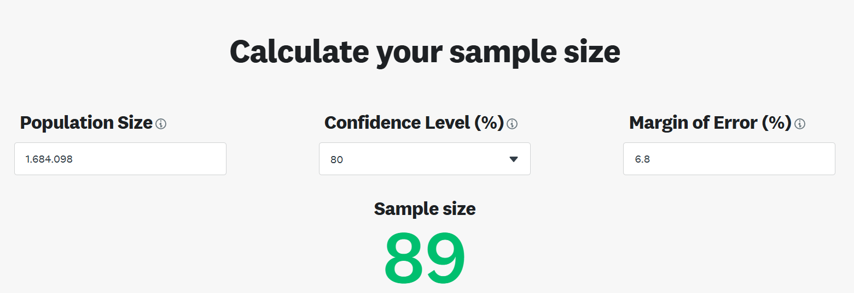
Figure 21: Sample Size Calculation for the End-User Survey

3.4.1 Participant Overview
Table 1 summarizes the planned and completed participant recruitment for both stakeholder and end-user surveys. A total of 14 responses were collected from PHC staff and project stakeholders out of the 20 planned participants. For the end-user survey, 74 valid responses were obtained from users of the Sehati application, MyGov application, and Ministry of Health (MOH) website, representing 83.1% of the planned sample size (74 out of 89). Although the stakeholder and end-user target sample sizes were not fully achieved, the collected responses provided sufficient insights to support the user requirements analysis and design decisions for the proposed Naraak platform.

Method | Target Participants | Number Planned | Number Completed
Survey | PHC staff and Project stakeholders | 20 | 14
Survey | End-user and general patient population (Sehati/MyGov/MOH users) | 89 | 74
Table 1: Participant Recruitment Overview

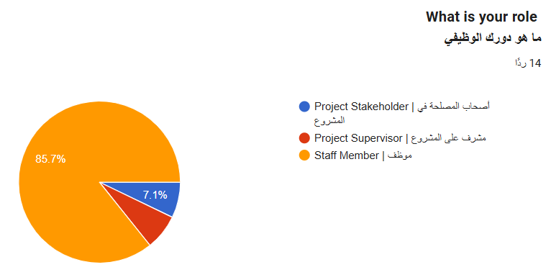
7.1%
Figure 22: Distribution of Stakeholder Survey Participants by Role
Figure 22 illustrates the distribution of stakeholder survey participants based on their roles. Among the 14 respondents, the majority were Staff Members, representing 85.7% of the participants. Project Supervisors accounted for 7.1% of responses, while Project Stakeholders represented 7.1%. The participant distribution indicates that the survey primarily captured insights from PHC staff members who are directly involved in or familiar with the existing digital healthcare services, while also including feedback from supervisory and stakeholder perspectives.

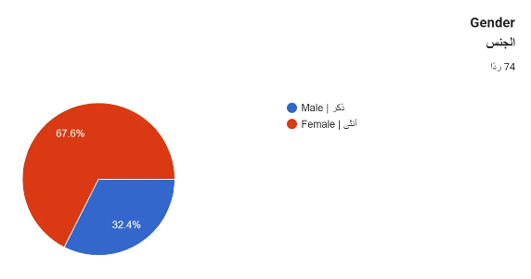
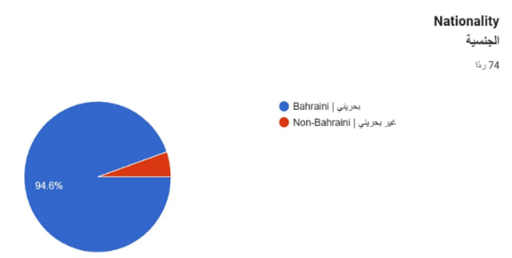
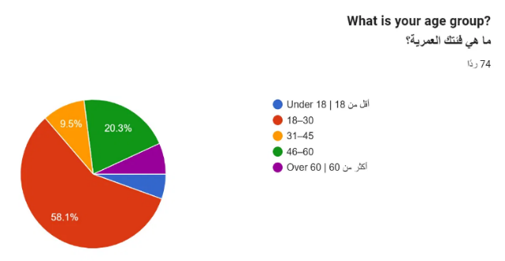

Figure 23: Demographic Distribution of Patient Survey Participants (Age Group, Gender, and Nationality)

Figure 23 illustrates the demographic distribution of the patient survey participants. A total of 74 respondents completed the survey. The largest age group was 18–30 years, representing 58.1% of participants, followed by 46–60 years (20.3%), 31–45 years (9.5%), while respondents under 18 and over 60 each accounted for approximately 6.1%. Female participants represented 67.6% of the sample, compared to 32.4% male participants. In terms of nationality, the survey predominantly captured responses from Bahraini participants (94.6%), with 5.4% identifying as non-Bahraini. Overall, the participant demographics indicate that the survey primarily reflects the experiences and perspectives of Bahraini adults, particularly those aged 18–30, while also including responses from a range of age groups and both genders.

3.5 Findings by Service
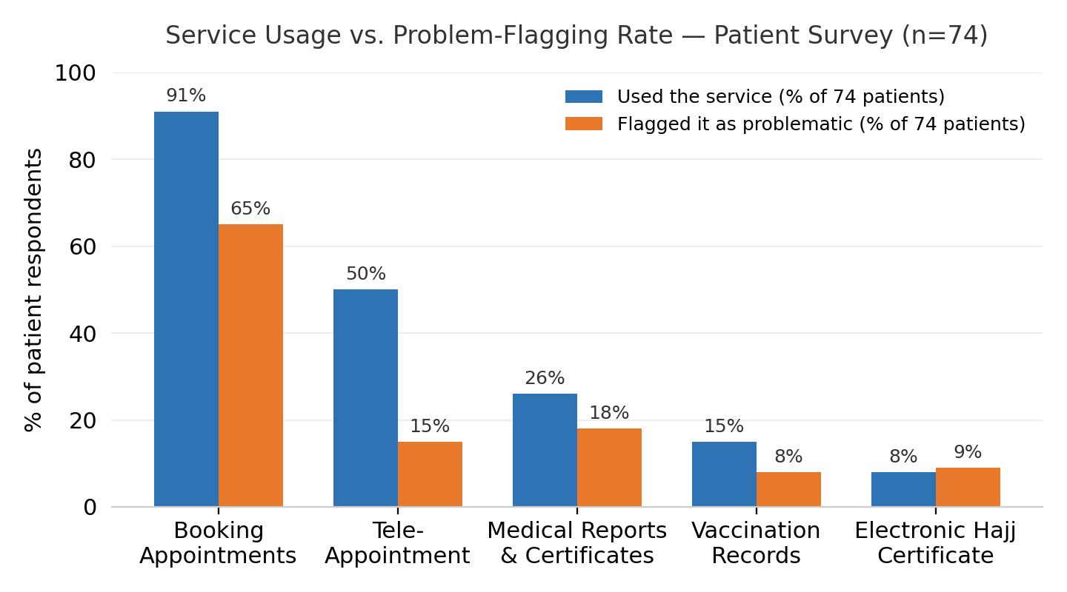
The following sections present findings per service, combining heuristic review observations with survey and interview data. Each section includes a current experience summary, pain points with severity and frequency, supporting evidence from respondents, and preliminary requirement implications.
Figure 24: Service usage vs. problem-flagging rate — patient survey (n=74).

3.5.1 Booking Appointments
Current Experience Summary

Booking is the most visible and most-used e-service in Sehati, with 91% of patient respondents (67 of 74) reporting they used it in the past 6–12 months, and 93% of stakeholders (13 of 14) interacting with it operationally. Despite strong awareness, it is also the most problematic service: 65% of patients (48 of 74) flagged it as causing the most problems, and 50% of stakeholders (7 of 14) confirmed it creates operational challenges.
The current flow is doctor-centric:
Pick specialty → Pick doctor → Check dates → Switch doctor if unavailable → Select date → Select time
Users who want the earliest available slot must repeat the doctor-selection step to compare availability. The dominant complaint across both surveys is appointment unavailability respondents described appointments as consistently full, limited to one or two doctors, or showing availability that does not match the actual health center schedule. Multiple respondents reported being forced to visit their health center in person because the digital booking showed no slots while the clinic itself was not busy. In addition, Session timeouts and system crashes during booking were reported by multiple respondents.

Pain Points Identified
Pain Point | Severity (H/M/L) | Frequency Reported
Doctor-first flow blocks users who prioritize timing over a specific doctor | H | 48/74 patients
Appointment slots shown as unavailable while health centers are not at capacity | H | ~30 mentions
No visible way to see all earliest available slots across doctors | H | Heuristic + survey
System crashes, timeouts, and 'out of order' errors during booking | H | ~10 mentions
No evening/night appointment slots available | M | 2 mentions
Dense UI with small tap targets — difficult for elderly users | M | Stakeholder + heuristic
No appointment reminders or notifications | M | Heuristic review
No dental appointment booking available through the app | M | 3 mentions

Supporting Evidence

Patient survey respondents described the following experiences (paraphrased and anonymized):
- P4: "Most of the time there are no appointments, or the system just doesn't work."
- P33: "No appointments available, but when you go to the center in person you find it nearly empty."
- P36: "Appointments not available most of the time and now it doesn't work unless I visit the health center to assign a family doctor."
- P41: "No appointments available at my health center with any doctor across multiple time periods I tried."
- P52: "Many [problems], mainly appointments filling up quickly and system glitches."
- P64: "Sehati relies on only one or two doctors, making it hard to book, forcing you to go to the health center."
- P74: "Appointments are unrealistic the system shows no availability, but when you go to the center, doctors have no patients."
- Stakeholder R4: "Since these services depend on external systems and are the most-used services, access should be easy and fast."

Preliminary Requirement Implications
- SRS-APT-001 — Support both doctor-first and time-first booking paths.
- SRS-APT-001 — Show all available slots across doctors in a single view.
- SRS-NFR-002 — Large tap targets, plain-language labels, elderly-friendly UI.
- SRS-NFR-003 — Core booking actions must complete within 3 seconds.
- SRS-NFR-004 — Atomic transactions with graceful recovery from failure.

3.5.2 Vaccination Records & Certificate
Current Experience Summary
Straightforward to use — viewing vaccination history and downloading records both work reliably for most users. The service was used by 15% of patients (11 of 74) and 36% of stakeholders (5 of 14). 8% of patients (6 of 74) flagged it as problematic, with the primary issues being missing records, slow response times during document operations, and session timeouts. Stakeholders confirmed that complaints about missing or incorrect vaccination records are reported.
Pain Points Identified
Pain Point | Severity (H/M/L) | Frequency Reported
Missing vaccination records not reflected in the system | H | Stakeholder R12
Frequent session timeouts cause loss of entered data | H | Heuristic + survey
System downtime without prior warning | H | Heuristic review
Slow response times when uploading documents | M | Heuristic + R2
Supporting Evidence
- Stakeholder R12: "Missing vaccines" identified as a recurring operational challenge.
- Stakeholder R2: "File size is too big, wrong format" — reported as upload/download issue.
- Stakeholder R4: "Users do not know the permitted file type or maximum upload size, and may select the wrong file by mistake."
- Patient P32: "There are no blood test reports available" — expectation mismatch on what records are included.
Preliminary Requirement Implications
- SRS-VAC-001 — Display comprehensive vaccination history with missing-record flagging.
- SRS-NFR-003 — Performance target of 3 seconds for core actions, progress indicators for uploads.
- SRS-NFR-004 — Atomic transactions, form-state persistence on timeout.
- SRS-NFR-005 — 99.5% availability, planned-maintenance notifications.
- SRS-UPL-001 — Validate uploaded file type and maximum file size before submission; provide clear guidance on supported formats and size limits.

3.5.3 Medical Reports & Certificates
Current Experience Summary
The second most-used service after booking (26% of patients, 50% of stakeholders), and the second most-prioritized for redesign (38% of patients, 64% of stakeholders). Easy and straightforward to use, with the needed services present (Laboratory, Radiology, and Medical Reports). However, the Medical Reports request form asks the user to type the consultant's name from memory. A better flow would let the user pick a category first (e.g. Laboratory, Radiology, General Clinic) and then choose their consultant from a filtered dropdown of doctors they've previously seen in that category — easier and less error-prone.
Patients requested the ability to download lab results and radiology reports directly through the app, and to simplify the process of obtaining medical excuses and certificates.

Pain Points Identified
Pain Point | Severity (H/M/L) | Frequency Reported
Consultant name entered as free text — no category filter, no past-visit lookup | M | Heuristic review
Lab and radiology results not downloadable through the app | H | P6, P32, P36
Medical excuses and certificates difficult to obtain digitally | M | P3
Supporting Evidence
- Patient P6: "I wish it were possible to download lab results and radiology reports."
- Patient P3: "Simplify obtaining medical excuses and reports."
- Patient P36: "Assignment of family doctor and access to test results and reports" needed.
- Patient P24: "Easier access to medical reports and vaccination records" requested.
Preliminary Requirement Implications
- SRS-REP-001 — Consultant field should be a searchable dropdown populated from visit history.
- SRS-REP-001 — Support digital download of lab and radiology results.
- SRS-NFR-002 — Category-first flow for users.

3.5.4 Electronic Hajj Certificate
Current Experience Summary
Only 8% of patients (6 of 74) attempted to request an Electronic Hajj Certificate, but 9% (7 of 74) flagged it as problematic — meaning some users who hadn't completed the flow still identified it as a pain point, likely based on failed attempts. The service displays "Not available" or "No Request Found" without distinguishing between states. One respondent confirmed the service simply does not work. And some complained that there was no description or explanation provided to the user regarding the reason for the service request failure. This is because the service does not clarify to the user that they must visit the doctor at the center to request the service and then obtain the certificate from the website.
Pain Points Identified
Pain Point | Severity (H/M/L) | Frequency Reported
Service reported as non-functional | H | P41, P57
Generic status message does not distinguish request states | H | Heuristic review
No visibility into certificate generation progress | H | Heuristic review
Pop-up blocker requirement is easy to miss | M | Heuristic review
Doctor-visit prerequisite not communicated to user before submission | H | Heuristic review; P41, P57
Supporting Evidence
- Patient P41: "Hajj certificate service does not work — shows as unavailable."
- Patient P57: "The service was not available from the start."
Preliminary Requirement Implications
- SRS-HAJ-001 — Add request status tracking (submitted → processing → ready).
- SRS-HAJ-001 — Display download guidance before certificate generation.
- SRS-HAJ-001 — Improve error messages for failed requests.
- SRS-HAJ-001 — Clearly state on the service page, that the certificate must first be requested in person from the doctor at the health center; the certificate only becomes available for download on the website after this in-person step is completed.

3.5.5 Tele-Appointment Instructions
Current Experience Summary
50% of patient respondents (37 of 74) reported using tele-appointments, making it the third most-used service. 15% (11 of 74) flagged it as problematic. The primary issues are: unclear instructions especially for elderly users, link delivery failures or delays, and the inability to retrieve a consultation link once the notification is missed. One respondent specifically noted that elderly users find the service confusing.
Stakeholders rated the service 3.8/5 for user-friendliness, and 29% (4 of 14) identified it as causing operational challenges. One stakeholder noted that patients refuse video consultations, suggesting trust or comfort issues with the format.

Pain Points Identified
Pain Point | Severity (H/M/L) | Frequency Reported
Consultation link cannot be retrieved after notification is missed | H | Heuristic + survey
Instructions unclear for elderly/less tech-savvy patients | H | P4, P24, P60
Link delayed or did not open properly | M | P24
No resend option for consultation link | M | Heuristic review
No translation of tele-appointment instructions into other languages | M | P57
Supporting Evidence
- Patient P4: "The explanation is not sufficient and not easy for the elderly."
- Patient P24: "The tele-appointment link was sometimes delayed or did not open properly. Instructions for joining were not always clear."
- Patient P60: "Instructions too wordy/long."
- Patient P74: "I don't know about this service — awareness should be spread to people."
- Stakeholder R3: "Patients refusing to consent to video consultation" — trust/comfort issue."
Preliminary Requirement Implications
- SRS-TEL-001 — Store tele-appointment links within appointment details for retrieval.
- SRS-TEL-001 — Allow users to resend consultation links.
- SRS-NFR-002 — Simplify instructions with visual step-by-step guide for elderly users.
- SRS-NFR-007 — Multilingual support for tele-appointment instructions.

3.5.6 Sehati Card Request for Newborns
Current Experience Summary
Parents request the newborn's Sehati Card in the MOH Website. Before any request exists, the screen shows only "No Request Found." The form requires manually typed Newborn CPR, Father CPR, and Mother CPR alongside contact details — none pre-filled from any registry — and there is no post-submission status indicator.
Pain Points Identified
Pain Point | Severity (H/M/L) | Frequency Reported
Newborn/parent CPR entered manually, not pulled from CIO birth registry | M | Heuristic review
No status tracking after submission | M | Heuristic review
Nearly all users who tried it hit a problem | H | 4% of patients (3/74) used it; 4% (3/74) flagged it problematic

Supporting Evidence (from survey)
4% of patients (3 of 74) used this service. 4% (3 of 74) flagged it as problematic. Low usage limits quantitative conclusions, but the heuristic findings (manual CPR entry, no status tracking) remain valid.
Preliminary Requirement Implications
- SRS-NB-001 — Auto-populate newborn CPR and parent details from CIO birth-registry data instead of manual entry.
- SRS-NFR-004 — Add request-status tracking (submitted → processing → issued) for the newborn Sehati card, consistent with other request-based services.

3.5.7 Update Residential Address
Current Experience Summary
Patients submit Requester CPR, Previous Block, New Block, and contact details, then confirm consent. The system reassigns the patient's health center behind the scenes, but the confirmation screen never names or displays the new center.
Pain Points Identified
Pain Point | Severity (H/M/L) | Frequency Reported
No confirmation of the newly assigned health center | H | 7% of patients flagged problems (5/74)
Problem-flagging exceeds actual usage | M | 3% used (2/74) vs 7% flagged (5/74)
High redesign priority despite low usage | M | 18% patients (13/74), 21% stakeholders (3/14)
Supporting Evidence (from survey)
3% of patients (2 of 74) used this service, but 7% (5 of 74) flagged it as problematic — suggesting awareness of issues even among non-users. 18% of patients (13 of 74) prioritized it for redesign, and 21% of stakeholders (3 of 14) agreed. The heuristic findings (unclear reassignment communication) are supported by the disproportionate problem-flagging rate.
Preliminary Requirement Implications
- SRS-ADR-001 — Clearly display the newly assigned health center immediately upon address update, with an in-app confirmation.
- SRS-NFR-002 — Simplify the reassignment flow to close the gap between low usage (3%) and disproportionate problem-flagging (7%).

3.5.8 Health Fee Exemption Card Issuance
Current Experience Summary
Applicants complete a single long page: request type (new/renew), personal and marital details, nationality, and up to six conditional document uploads, ending in one consent checkbox. Nothing previews which documents are required before the applicant starts, and there's no status tracker after submission.
Pain Points Identified
Pain Point | Severity (H/M/L) | Frequency Reported
No upfront checklist of required documents | M | Heuristic review
Long single-page form increases cognitive load | M | Heuristic review
No post-submission status tracking | M | Heuristic review
Fourth most operationally challenging service for staff | H | 29% of stakeholders (4/14)
Supporting Evidence (from survey)
4% of patients (3 of 74) used this service. 29% of stakeholders (4 of 14) identified it as causing operational challenges — the fourth most-challenged service operationally. The heuristic findings about complex document requirements and cognitive load from a long single-page form are validated by the operational challenge rate.
Preliminary Requirement Implications
- SRS-EXM-001 — Present required documents as an upfront checklist and split the current long single-page form into shorter steps.
- SRS-NFR-004 — Allow applicants to track exemption request status after submission.
- SRS-UPL-001 — Validate uploaded file type and maximum file size before submission; provide clear guidance on supported formats and size limits.

3.5.9 Request Mobile Unit Service
Current Experience Summary
The home-visit request form collects Patient CPR, Contact Number, Block Number, Address, and a free-text reason. Though the service targets elderly/disabled patients, the form uses standard text fields with no accessibility accommodations and no status tracking.
Pain Points Identified
Pain Point | Severity (H/M/L) | Frequency Reported
No accessibility accommodations for the target audience | M | Heuristic review
No status tracking after submission | L | Heuristic review
High redesign priority despite low personal usage | M | 16% prioritized (12/74) vs 4% used (3/74)
Supporting Evidence (from survey)
4% of patients (3 of 74) used this service, and 3% (2 of 74) flagged problems. 16% (12 of 74) prioritized it for redesign — a notably high prioritization rate for a low-usage service, suggesting patients recognize its importance for elderly/disabled users even if they don't personally use it.
Preliminary Requirement Implications
- SRS-MOB-001 — Ensure the mobile-unit request flow meets the elderly/disability-accessibility bar in SRS-NFR-002, given this service's core audience.

3.5.10 Mammogram Appointment Requests
Current Experience Summary
The form asks only for Contact Number, Second Contact Number, and a self-declared consent statement confirming no mammogram in the last two years. There is no age-eligibility check or verification against screening history.
Pain Points Identified
Pain Point | Severity (H/M/L) | Frequency Reported
Eligibility relies on self-declaration, not registry check | H | Heuristic review
Very low usage limits confidence | L | 1% used (1/74), 3% flagged problems (2/74)
Supporting Evidence (from survey)
1% of patients (1 of 74) used the service, and 3% (2 of 74) flagged problems. Low usage limits survey-based conclusions. The heuristic finding that eligibility relies on self-declaration rather than system verification remains the primary concern.
Preliminary Requirement Implications
- SRS-MAM-001 — Verify screening eligibility (age criteria) against registry data rather than relying on user self-declaration alone.

3.5.11 Change Family Doctor
Current Experience Summary
Patient CPR, Name, Current Health Center, and Current Family Doctor are read-only. Users can only type a Requested Family Doctor and a reason — no browsing or availability view. Several patients report a first doctor assignment requires an in-person center visit before the app functions at all.
Pain Points Identified
Pain Point | Severity (H/M/L) | Frequency Reported
No way to browse/select doctors by real-time capacity | H | Heuristic, supported by patient quotes
In-person visit required before first doctor assignment | H | Patient P36
Patients feel they have no real choice of doctor | M | Patient P64
Disproportionate problem-flagging and high prioritization | M | 3% used (2/74), 8% flagged (6/74), 19% prioritized (14/74)
Supporting Evidence (from survey)
3% of patients (2 of 74) used this service, but 8% (6 of 74) flagged it as problematic, and 19% (14 of 74) prioritized it for redesign. Multiple respondents mentioned difficulty getting a family doctor assigned as a prerequisite to booking appointments. One respondent noted the app does not work without first visiting the health center to assign a family doctor.
- Patient P25: "It's hard to get a family doctor easily."
- Patient P36: "It doesn't work unless I visit the health center to appoint a family doctor."
- Patient P64: "No freedom in choosing doctors."
Preliminary Requirement Implications
- SRS-DOC-001 — Let patients browse available family doctors and see real-time capacity before requesting reassignment (covers both the change-doctor request and the doctor-capacity-verification requirement sharing this ID in the source requirements list).
- SRS-NFR-002 — Remove the in-person visit currently required to assign a family doctor as a prerequisite for booking.

3.5.12 Primary Healthcare Research Applications
Current Experience Summary
Researchers select an applicant type, then fill in contact and research metadata, uploading up to four documents. Some upload fields state accepted file formats explicitly; others give no guidance at all.
Pain Points Identified
Pain Point | Severity (H/M/L) | Frequency Reported
Inconsistent/missing file-type guidance on upload fields | M | Patient P57
Real operational friction for staff despite niche patient audience | M | 14% of stakeholders (2/14)
Supporting Evidence (from survey)
4% of patients (3 of 74) used this service, and 3% (2 of 74) flagged problems. 14% of stakeholders (2 of 14) identified operational challenges. This is a niche service for researchers, not patients — low patient usage is expected. One respondent noted that upload file type requirements are unclear.
- Patient P57: "Many inputs where the required file type was not specified."
Preliminary Requirement Implications
- SRS-RES-001 — Specify accepted file types and maximum size explicitly on every upload field in the research-application form.
- SRS-UPL-001 — Validate uploaded file type and maximum file size before submission; provide clear guidance on supported formats and size limits.

4. Cross-Cutting / Non-Functional Findings

4.1 Performance
Stakeholders rated platform performance/speed (1–5, where 5 = very fast) at: Sehati 4.0/5, MyGov 3.5/5, MOH website 3.4/5. The patient survey did not include a direct performance/speed question, though patients rated ease of finding and completing PHC services at: Sehati 3.5/5, MyGov 3.3/5, MOH website 3.0/5 — indicating that even the best-performing platform barely exceeds neutral on usability.
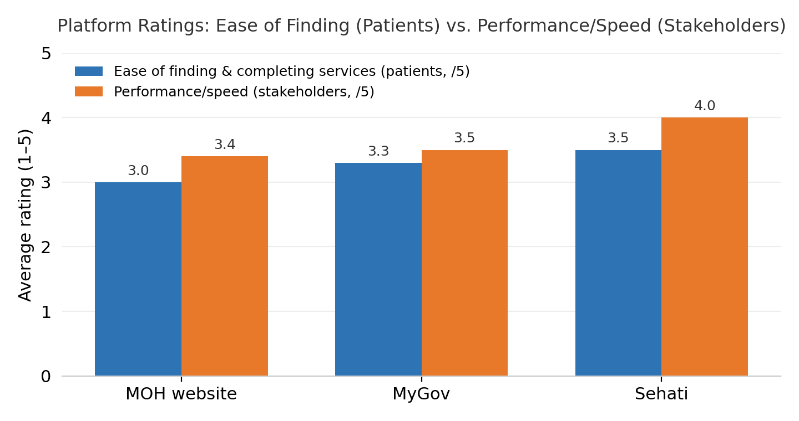
Figure 25: Platform ratings: ease of finding & completing services (patients) vs. performance/speed (stakeholders).

Multiple patients described the system as "slow," "lagging," or "crashing." One respondent (P12) specifically noted: "It lags and needs a better and easier to use UI." Another (P24) cited "slow loading times" as the most frustrating aspect. Stakeholder R6 identified "delay in receiving the service" as the primary challenge.

4.2 Availability & Reliability
Patients rated error/outage frequency at approximately 3.1/5 across all three platforms (where 5 = rarely encounters errors). This neutral-to-negative score indicates regular reliability issues. Multiple respondents described the system as being "out of order" (P48), "not working" (P50), or experiencing "system glitches" (P53). Patient P60 summarized the issue: "System down, uploads don't work, unclear instructions." Stakeholder R7 noted that network availability is a barrier to continuous service delivery. in the Sehati booking e-service, it faces significant reliability issues, as evidenced by frequent system crashes, session timeouts during booking, and inaccurate slot availability that fails to reflect actual clinic schedules.

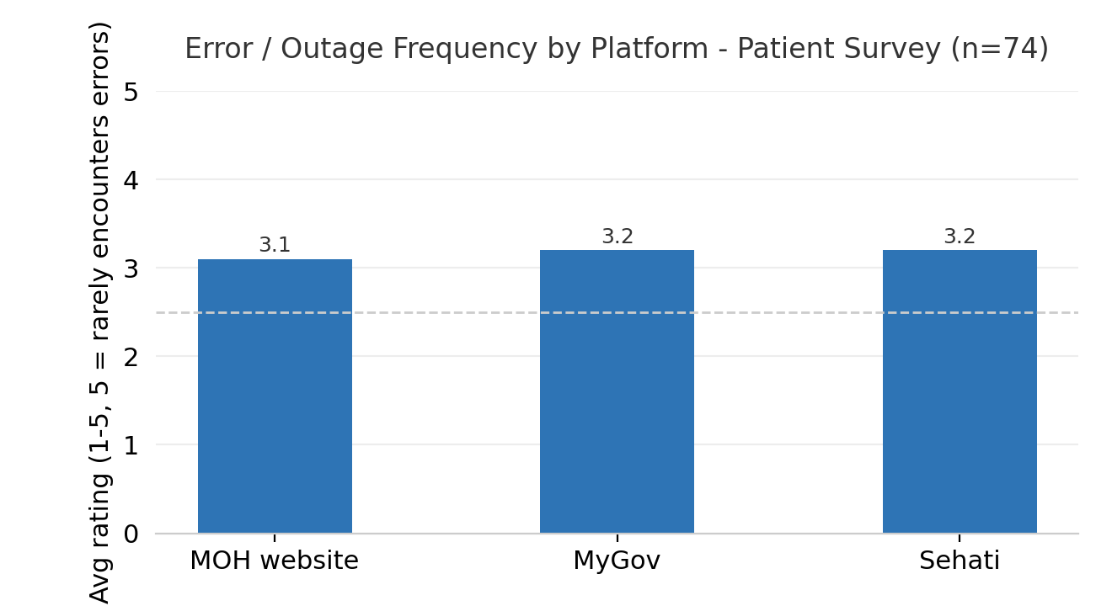
Figure 26: Error/outage frequency by platform — patient survey (n=74).

4.3 Accessibility
Patients rated the adequacy of text size, contrast, and navigation at 3.5/5. Design ease of use was rated 3.4/5. Both scores hover near neutral, suggesting room for improvement.
The most-requested accessibility features from patients were: simple and clear navigation (68%), screen reader compatibility (49%), larger text size (47%), multilingual support (42%), and high-contrast mode (38%). Stakeholders showed a similar pattern: simple navigation (64%), multilingual support (50%), screen reader support (43%), larger text (36%), and high-contrast (29%). Light/dark mode was requested by 10% of patients. 64% of stakeholders said the app should support both light and dark modes.
Display preference split evenly between grid view/cards (46%), frequently-used-first ordering (46%), and categorized sections (43%). List view was preferred by 30%. This supports a card-based layout with frequency-based ordering — exactly what the proposed Naraak sitemap uses.
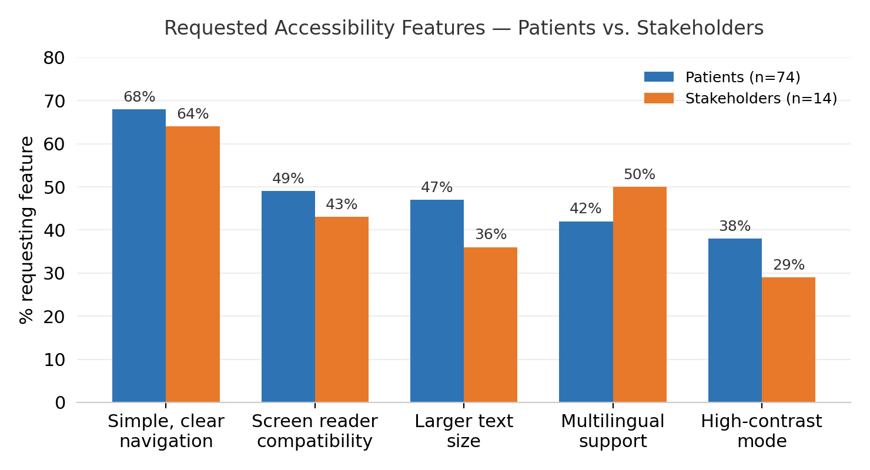
Figure 27: Requested accessibility features — patients vs. stakeholders.

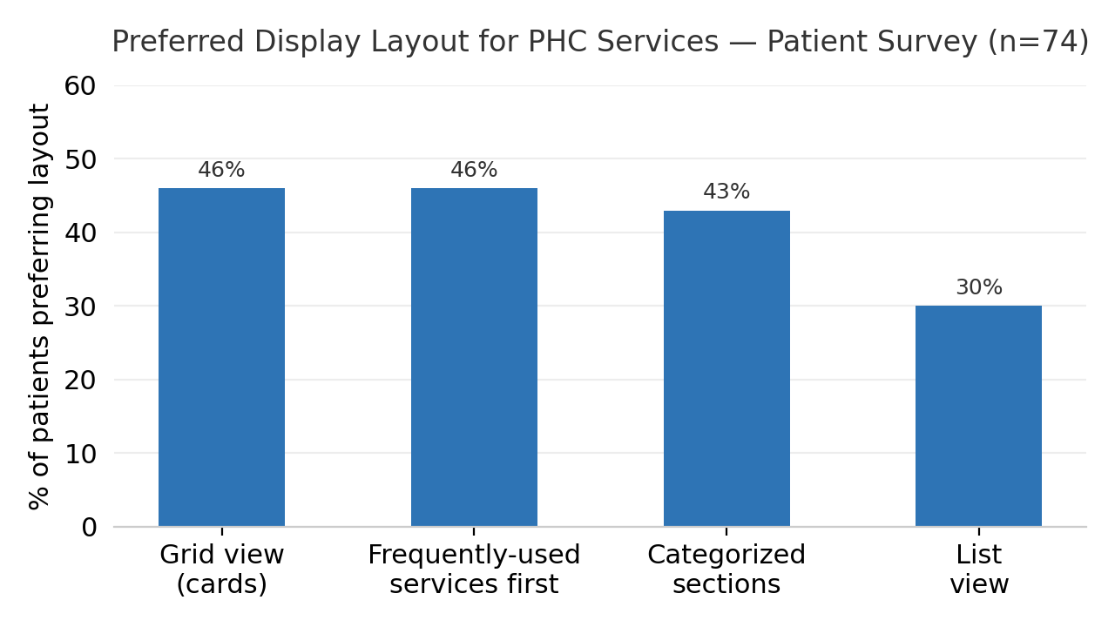
Figure 28: Preferred display layout for PHC services — patient survey (n=74).

4.4 Localization
42% of patients and 50% of stakeholders requested multilingual support. One patient (P57) specifically noted the absence of translations for tele-appointment instructions. Another (P45) reported Arabic text with spelling errors and unclear phrasing. The Naraak platform must support full Arabic and English with proper RTL layout, as specified in SRS-NFR-007.

4.5 Security & Privacy Perception
No patients or stakeholders raised unprompted data security concerns in the open-ended questions. However, the survey did not include a direct trust question, so the absence of complaints should not be interpreted as confirmed confidence. The eKey authentication requirement (SRS-EKY-001) and encryption requirements (SRS-NFR-001) provide the security foundation.

Note: The implementation of these security mechanisms, including authentication handling and data encryption, is considered a backend responsibility and is assumed to be addressed within the backend system design and implementation.

4.6 Platform-Level Features
eKey login: No specific complaints about eKey authentication were raised, though one stakeholder (R4) noted that services depending on external systems need seamless integration. Family management: One patient (P45) described being unable to find a grandmother's record through CPR lookup despite entering the correct ID — suggesting family member linking has gaps (SRS-FAM-001). Feedback: Stakeholder R12 recommended adding post-service satisfaction surveys. One patient specifically requested in-app customer support for when issues arise. Settings: 64% of stakeholders supported both light and dark mode support.

4.7 Non-Functional Requirements Not Surfaced in Phase 1
Two of the eight non-functional requirements in the source requirements list were not evidenced by Phase 1 data: SRS-NFR-006 (Compatibility across mobile OS versions and browsers) and SRS-NFR-008 (Legal & Ethical / MOH data-protection compliance). Neither the patient survey, the stakeholder interviews, nor the heuristic review surfaced complaints or observations in these areas as compatibility and compliance are typically validated through technical testing and legal review rather than end-user feedback, and both remain in scope for Phase 2 and the SRS regardless of this gap.

5. Prioritized Pain Point Summary
Consolidated across all services and ranked by severity, frequency, and impact. This table is the primary reference for Phase 2 prioritization.
Rank | Service | Pain Point | Severity | Frequency | Impact
1 | Booking | Slots shown as unavailable while centers are not at capacity | H | ~30 patients | Critical
2 | Booking | Doctor-first flow blocks users who want earliest slot | H | 48/74 (65%) | Critical
3 | Booking | System crashes, timeouts during booking | H | ~10 patients | High
4 | Medical Reports | Lab/radiology results not downloadable | H | Multiple | High
5 | Tele-Appt | Link cannot be retrieved once notification is missed | H | Survey + heuristic | High
6 | Tele-Appt | Instructions unclear for elderly users | H | P4, P24, P60 | High
7 | Hajj Cert | Service non-functional / shows unavailable | H | P41, P57 | High
8 | Change Doctor | Cannot see doctor availability before requesting | H | 6/74 flagged | Medium
9 | Fee Exemption | Document requirements not presented upfront | H | 4/14 staff | Medium
10 | Cross-cutting | Fragmentation: PHC services scattered across 3 platforms | H | Systemic | Critical
11 | Cross-cutting | Ease of finding PHC services rated 3.0–3.5/5 | M | 74 patients | High
12 | Cross-cutting | Error/outage frequency rated 3.1/5 across platforms | M | 74 patients | High

6. Product Requirements
ID | Title | Priority | Description
SRS-EKY-001 | Authenticate via eKey | High | Users shall log in using national eKey credentials before accessing any PHC e-service.
SRS-APT-001 | Book PHC Appointment | High | Users shall book, reschedule, or cancel an appointment at their registered PHC center.
SRS-VAC-001 | View Vaccination Records & Certificates | High | Users shall view and download vaccination history and certificates.
SRS-NB-001 | Issue Newborn Sehati Card | High | A parent shall issue a digital Sehati Card for a newborn using CIO birth-registry data.
SRS-ADR-001 | Update Address & PHC Re-allocation | High | Users shall sync their official address and be reassigned to the nearest PHC center.
SRS-HAJ-001 | Request Electronic Hajj Certificate | High | The system update the Hajj medical certificate service to feature automated eligibility verification and secure QR-code issuance, incorporating request status tracking, clear error messages, download guidance, and explicit instructions that the certificate must first be requested in person from the health center doctor before online download becomes available.
SRS-MAM-001 | Book Mammogram Appointment | High | Eligible female users (based on national age criteria) shall be able to schedule, reschedule, or cancel screening appointments.
SRS-EXM-001 | Apply for Health Fee Exemption Card | Medium | Users shall submit an exemption application with documents and track its status.
SRS-TEL-001 | Access Tele-appointment Instructions | Medium | Users shall view interaction guides and dynamic status/access links for their upcoming remote consultations.
SRS-MOB-001 | Request Mobile Medical Unit | Medium | A patient or verified family member shall request a home visit.
SRS-DOC-001 | Change Family Doctor | Medium | Users shall browse available doctors and request reassignment.
SRS-FAM-001 | Manage Family Member Profiles | Medium | Users shall view and manage linked family member profiles.
SRS-REP-001 | Request Medical Reports & Certificates | Medium | Users shall submit requests for official medical reports from past visits, pay fees if applicable, and download signed digital copies.
SRS-DCV-001 | Doctor Capacity Verification | Medium | The system shall automatically verify that the selected family doctor has available quota before confirming reassignment
SRS-RES-001 | Submit PHC Research Application | Low | Researchers shall submit and track research proposals.
6.1 Functional Requirements

6.2 Non-Functional Requirements
ID | Title | Priority | Description
SRS-NFR-001 | Security | High | All user and government-registry data shall be encrypted in transit and at rest.
SRS-NFR-002 | Usability & Accessibility | High | Large tap targets, high-contrast text, and minimal steps shall support elderly and determined patients.
SRS-NFR-003 | Performance | Medium | Core actions (e.g. center matching) shall complete within 3 seconds under normal conditions.
SRS-NFR-004 | Reliability | High | Critical transactions (e.g. card issuance) shall be atomic and recover gracefully from failure.
SRS-NFR-005 | Availability | Medium | Core PHC services shall remain available 99.5% of the time.
SRS-NFR-006 | Compatibility | Medium | The app shall function consistently across supported mobile OS versions and modern browsers.
SRS-NFR-007 | Localization | High | The system shall support Arabic and English, including full right-to-left layout.
SRS-NFR-008 | Legal & Ethical Compliance | High | The system shall comply with MOH and government data-protection standards.

7. Recommendations
The following recommendations feed directly into Phase 2 (service priorities, personas, user journeys). These are directional — not full solution designs.
1. Prioritize booking appointments as the highest-impact redesign target.
With 91% usage and 65% problem rate, booking is the single service that will define whether Naraak succeeds or fails in users' eyes. The redesign must introduce a time-first booking path alongside the existing doctor-first path and address the slot availability gap between what the app shows and what health centers actually have.
2. Consolidate PHC services into a single dedicated platform.
The fragmentation finding is systemic: patients use 3 platforms, and ease-of-finding scores are lowest on the MOH website (3.0/5). Naraak's core value proposition — one place for all PHC services — is validated by the data.
3. Build an patient-first information architecture.
68% of patients requested simple/clear navigation. Display preference data supports a card-based layout with frequently-used services first. The sitemap should use a maximum of 4 top-level categories with 2-tap maximum depth to any service.
4. Invest in reliability before adding new features.
User feedback indicates that system reliability is an urgent area requiring attention. Error/outage scores of 3.1/5, along with patients reporting that they abandoned digital services and visited health centers physically instead, highlight the impact of reliability issues on user satisfaction. While identifying these concerns is within the scope of this evaluation, implementing fixes related to availability, performance, and outage handling falls outside the current phase and under the development and backend stages. The defined performance targets (3-second response time and 99.5% availability) should be prioritized to ensure a reliable digital healthcare experience.
5. Add status tracking across all request-based services.
Hajj certificate, newborn Sehati card, fee exemption card, mobile unit service, and research applications all lack post-submission visibility. A unified request tracker — visible from the home screen — would address this across five services simultaneously.
6. Provide downloadable lab and radiology results.
Multiple patients explicitly requested this. It bridges the gap between what Medical Reports & Certificates offers (request a formal report) and what patients actually want (quickly see my latest blood test results).
7. Simplify tele-appointment onboarding for users.
Replace the current text-heavy instruction infographic with a 3-step visual guide. Store consultation links within appointment details so missed notifications don't block access. Consider adding a "test my setup" button before the appointment.
8. Support both Arabic and English with proper RTL layout.
42–50% of respondents requested multilingual support. Arabic spelling errors were noted in the current platforms. Naraak must treat localization as a core requirement (SRS-NFR-007), not a post-launch enhancement.

References
Naraak Project (الردود) [Data set]. (2026). SharePoint. Retrieved August 6, 2026, from https://phcbh-my.sharepoint.com/:x:/g/personal/fdarraj_phc_gov_bh/IQCoyp0jt2XcR7zc1qmXqfIyAVCrsTeTjsy-NoHv-dkUm7M?e=3vpOrg
Naraak Project: Patient & End-User Feedback Survey مشروع نرعاك: استبيان آراء المرضى والمستخدمين (الردود) [Data set]. (2026). SharePoint. Retrieved August 6, 2026, from https://phcbh-my.sharepoint.com/:x:/g/personal/fdarraj_phc_gov_bh/IQAsfLSGBGpuTaQE0jnI5NuAAXons6iyUPgW8CrcMd6tzxc?e=Dz9wn7
SurveyMonkey. (n.d.). Sample size calculator: Determine your sample size. SurveyMonkey. Retrieved August 6, 2026, from https://www.surveymonkey.com/learn/research-and-analysis/sample-size-calculator/

Worldometer. (2026). Bahrain population. Worldometer. Retrieved August 6, 2026, from https://www.worldometers.info/world-population/bahrain-population/

Appendix A: Stakeholder Survey (Questionnaire-1)
Section 1: About You | القسم الأول: نبذة عنك
1. ما هو دورك الوظيفي؟
What is your role?
☐ أصحاب المصلحة في المشروع | Project Stakeholder
☐ مشرف على المشروع | Project Supervisor
☐ موظف | Staff Member
☐ أخرى | Other: ___________

2. أي من المنصات التالية تستخدمها بشكل متكرر للوصول إلى خدمات الرعاية الصحية الأولية؟
Which platform do you most frequently use when accessing PHC services?
☐ موقع وزارة الصحة | MOH Website
☐ تطبيق حكومتي | MyGov Application
☐ تطبيق صحتي | Sehati Application

3. من واقع ملاحظتك، ما مدى سهولة عثور المرضى على خدمات الرعاية الصحية الأولية ضمن الخدمات الأخرى المتوفرة في موقع وزارة الصحة؟
Based on your experience, how easy is it for patients to find PHC-specific services on the MOH website?
صعب ☐ 1 ☐ 2 ☐ 3 ☐ 4 ☐ 5 ☐ سهل

4. من واقع ملاحظتك، ما مدى سهولة عثور المرضى على خدمات الرعاية الصحية الأولية ضمن الخدمات الأخرى المتوفرة في تطبيق حكومتي؟
Based on your experience, how easy is it for patients to find PHC-specific services on the MyGov application?
صعب ☐ 1 ☐ 2 ☐ 3 ☐ 4 ☐ 5 ☐ سهل

5. من واقع ملاحظتك، ما مدى سهولة عثور المرضى على خدمات الرعاية الصحية الأولية ضمن الخدمات الأخرى المتوفرة في تطبيق صحتي؟
Based on your experience, how easy is it for patients to find PHC-specific services on the Sehati application?
صعب ☐ 1 ☐ 2 ☐ 3 ☐ 4 ☐ 5 ☐ سهل

Section 2: Service-Specific Operational Feedback | القسم الثاني: ملاحظات تشغيلية حول خدمات محددة
1. ما هي الخدمات الإلكترونية للرعاية الصحية الأولية التي تعاملت معها (بصفتك الوظيفية/التشغيلية) خلال آخر 6–12 شهراً؟
(يمكن اختيار أكثر من إجابة)
☐ حجز المواعيد | Booking Appointments
☐ سجل وشهادات التطعيم | Vaccination Records & Certificates
☐ التقارير والشهادات الطبية | Medical Reports & Certificates
☐ شهادة الحج الإلكترونية | Electronic Hajj Certificate
☐ طلب بطاقة صحتي للمواليد | Sehati Card Request for Newborns
☐ تحديث العنوان السكني | Update Residential Address
☐ بطاقة إعفاء الرسوم الصحية | Health Fee Exemption Card Issuance
☐ طلب خدمة الوحدة المتنقلة | Request Mobile Unit Service
☐ طلبات حجز مواعيد تصوير الثدي | Mammogram Appointment Requests
☐ طلب تغيير طبيب الأسرة | Requests to Change the Family Doctor
☐ طلبات إجراء بحوث الرعاية الصحية الأولية | PHC Research Application Requests
☐ إرشادات المواعيد عن بُعد | Tele-Appointment Instructions

2. ما الخدمات التي تسبب أكبر التحديات التشغيلية؟
(يمكن اختيار أكثر من إجابة)
☐ حجز المواعيد
☐ سجل وشهادات التطعيم
☐ التقارير والشهادات الطبية
☐ شهادة الحج الإلكترونية
☐ بطاقة صحتي للمواليد
☐ تحديث العنوان السكني
☐ بطاقة إعفاء الرسوم الصحية
☐ خدمة الوحدة المتنقلة
☐ مواعيد تصوير الثدي
☐ تغيير طبيب الأسرة
☐ طلبات البحوث
☐ المواعيد عن بُعد

3. ما التحديات التشغيلية التي تسببها هذه الخدمات؟
..............................................................................

4. ما خدمات الرعاية الصحية الأولية التي ينبغي إعطاؤها الأولوية لإعادة التصميم لتحسين تجربة المرضى؟
..............................................................................

5. إذا كانت الخدمة تتطلب رفع أو تحميل مستندات، فما أكثر المشكلات شيوعًا التي يواجهها المستخدمون؟
6. ما مدى سهولة استخدام خدمة الموعد عن بُعد؟
صعب ☐ 1 ☐ 2 ☐ 3 ☐ 4 ☐ 5 ☐ سهل

7. هل واجهت أو تلقيت بلاغات من المرضى بشأن مشكلات في استلام أو استخدام رابط الموعد عن بُعد؟ إذا كانت الإجابة نعم، فما أكثر المشكلات شيوعًا؟
..............................................................................

Section 3: Platform-Level Features | القسم الثالث: الميزات على مستوى المنصة

1. ما ميزات إمكانية الوصول التي ينبغي تضمينها لدعم جميع المستخدمين بشكل أفضل؟
Which accessibility features should be included to better support all users?
(يمكن اختيار أكثر من إجابة | Select all that apply)
☐ تكبير حجم النص | Larger text size
☐ وضع التباين العالي | High-contrast mode
☐ التوافق مع قارئات الشاشة | Screen reader compatibility
☐ دعم لغات متعددة | Multilingual support
☐ تنقل بسيط وواضح | Simple and clear navigation
☐ أخرى | Other: ___________

2. كيف تفضل عرض خدمات الرعاية الصحية الأولية؟
How would you prefer PHC services to be displayed?
☐ عرض شبكي على شكل بطاقات | Grid view (cards)
☐ عرض على شكل قائمة | List view
☐ عرض الخدمات ضمن أقسام مصنفة | Categorized sections
☐ عرض الخدمات الأكثر استخدامًا أولاً | Frequently used services first
☐ اقتراحات مخصصة حسب احتياجات المستخدم | Personalized recommendations

3. ما اللون أو الهوية اللونية التي تعتقد أنها الأنسب لمنصة نرعاك؟
Which color theme do you think is most suitable for the Nuraak platform?
..............................................................................

4. هل ينبغي أن تدعم منصة نرعاك الوضعين الفاتح والداكن؟
Should the Nuraak platform support both Light Mode and Dark Mode?
☐ الوضع الفاتح فقط | Light only
☐ الوضع الداكن فقط | Dark only
☐ كلا الوضعين (الفاتح والداكن) | Both
☐ لا أفضلية لدي | No preference

5. هل توجد أي ميزات أو وظائف في المنصة ترغب في إضافتها أو إزالتها أو تحسينها؟ يرجى التوضيح.
Are there any platform features you would like to add, remove, or improve? Please specify.
..............................................................................

Section 4: System Quality & Cross-Cutting Requirements | القسم الرابع: جودة النظام والمتطلبات المشتركة

1. ما الجوانب غير الوظيفية التي تحتاج إلى أكبر قدر من التحسين عبر خدمات الرعاية الصحية الأولية الرقمية؟
Which non-functional aspects require the most improvement across PHC digital services?
(يمكن اختيار أكثر من إجابة | Select all that apply)
☐ الأداء | Performance
☐ إمكانية الوصول | Accessibility
☐ سهولة الاستخدام | Ease of use
☐ سهولة التنقل | Navigation
☐ التكامل بين الأنظمة | Integration between systems
☐ أخرى | Other: ___________

2. هل توجد أي معوقات تقلل من كفاءة تقديم خدمات الرعاية الصحية الأولية الرقمية؟
Are there any barriers that reduce efficiency when delivering PHC digital services?
..............................................................................

3. كيف تقيّم أداء وسرعة تطبيق صحتي في الإجراءات الشائعة من الناحية التشغيلية؟
How would you rate Sehati performance/speed for common actions, from an operational point of view?
بطيء جدًا ☐ 1 ☐ 2 ☐ 3 ☐ 4 ☐ 5 ☐ سريع جدًا
Very Slow ☐ 1 ☐ 2 ☐ 3 ☐ 4 ☐ 5 ☐ Very Fast

4. كيف تقيّم أداء وسرعة تطبيق حكومتي لخدمات مراكز الرعاية الصحية الأولية؟
How would you rate MyGov performance/speed for common Primary Health Care services?
بطيء جدًا ☐ 1 ☐ 2 ☐ 3 ☐ 4 ☐ 5 ☐ سريع جدًا
Very Slow ☐ 1 ☐ 2 ☐ 3 ☐ 4 ☐ 5 ☐ Very Fast

5. كيف تقيّم أداء وسرعة موقع وزارة الصحة لخدمات مراكز الرعاية الصحية الأولية؟
How would you rate MOH website performance/speed for common Primary Health Care services?
بطيء جدًا ☐ 1 ☐ 2 ☐ 3 ☐ 4 ☐ 5 ☐ سريع جدًا
Very Slow ☐ 1 ☐ 2 ☐ 3 ☐ 4 ☐ 5 ☐ Very Fast

Section 5: Open-Ended Questions | القسم الخامس: الأسئلة المفتوحة

1. كيف يمكن تحسين التصميم وسير العمل العام لخدمات الرعاية الصحية الأولية الرقمية؟
How can the overall design and workflow of PHC digital services be improved?
..............................................................................

2. يرجى تقديم أي توصيات إضافية لتحسين خدمات الرعاية الصحية الأولية الرقمية من خلال منصة نرعاك.
Please provide any additional recommendations for improving PHC digital services through the Nuraak platform.
..............................................................................

Appendix B: Patient/End-user Survey (Questionnaire-2)
Nuraak Platform User Survey

Section 1: About You | القسم الأول: نبذة عنك

1. ما هي فئتك العمرية؟
What is your age group?
☐ أقل من 18 | Under 18
☐ 18–30
☐ 31–45
☐ 46–60
☐ أكثر من 60 | Over 60

2. الجنس
Gender
☐ ذكر | Male
☐ أنثى | Female

3. الجنسية
Nationality
☐ بحريني | Bahraini
☐ غير بحريني | Non-Bahraini

Section 2: General Experience | القسم الثاني: التجربة العامة

1. ما المنصة (أو المنصات) التي تستخدمها للوصول إلى الخدمات الإلكترونية لمراكز الرعاية الصحية الأولية؟
Which platform or platforms do you use to access Primary Healthcare Centers (PHC) e-services?
(يمكن اختيار أكثر من إجابة | Select all that apply)
☐ موقع وزارة الصحة | MOH Website
☐ تطبيق حكومتي | MyGov App
☐ تطبيق صحتي | Sehati App

2. ما خدمات مراكز الرعاية الصحية الأولية الإلكترونية التي استخدمتها خلال آخر 6–12 شهرًا؟
Which PHC e-services have you used in the past 6–12 months?
(يمكن اختيار أكثر من إجابة | Select all that apply)
☐ حجز المواعيد | Booking Appointments
☐ سجل وشهادات التطعيم | Vaccination Records & Certificates
☐ التقارير والشهادات الطبية | Medical Reports & Certificates
☐ شهادة الحج الإلكترونية | Electronic Hajj Certificate
☐ طلب بطاقة صحتي للمواليد | Sehati Card Request for Newborns
☐ تحديث العنوان السكني | Update Residential Address
☐ بطاقة إعفاء الرسوم الصحية | Health Fee Exemption Card Issuance
☐ طلب خدمة الوحدة المتنقلة | Request Mobile Unit Service
☐ طلبات حجز مواعيد تصوير الثدي | Mammogram Appointment Requests
☐ طلب تغيير طبيب الأسرة | Requests to Change the Family Doctor
☐ طلبات إجراء بحوث مراكز الرعاية الصحية الأولية | PHC Research Application Requests
☐ إرشادات المواعيد عن بُعد | Tele-Appointment Instructions

3. ما الخدمات التي واجهت أكبر عدد من المشكلات عند استخدامها؟
Which services have caused you the most problems?
(يمكن اختيار أكثر من إجابة | Select all that apply)
☐ حجز المواعيد
☐ سجل وشهادات التطعيم
☐ التقارير والشهادات الطبية
☐ شهادة الحج الإلكترونية
☐ طلب بطاقة صحتي للمواليد
☐ تحديث العنوان السكني
☐ بطاقة إعفاء الرسوم الصحية
☐ طلب خدمة الوحدة المتنقلة
☐ طلبات حجز مواعيد تصوير الثدي
☐ طلب تغيير طبيب الأسرة
☐ طلبات إجراء بحوث مراكز الرعاية الصحية الأولية
☐ إرشادات المواعيد عن بُعد

4. إن وجد، ما المشكلات التي واجهتها أثناء استخدام هذه الخدمات؟ يرجى توضيحها.
If applicable, what problems did you experience while using these services? Please describe.
..............................................................................

5. برأيك، ما الخدمات الإلكترونية التابعة لمراكز الرعاية الصحية الأولية التي ينبغي إعطاؤها الأولوية لإعادة التصميم لتحسين تجربة المرضى؟
Which PHC e-services should be prioritized for redesign to improve the patient experience?
(يمكن اختيار أكثر من إجابة | Select all that apply)
☐ حجز المواعيد
☐ سجل وشهادات التطعيم
☐ التقارير والشهادات الطبية
☐ شهادة الحج الإلكترونية
☐ طلب بطاقة صحتي للمواليد
☐ تحديث العنوان السكني
☐ بطاقة إعفاء الرسوم الصحية
☐ طلب خدمة الوحدة المتنقلة
☐ طلبات حجز مواعيد تصوير الثدي
☐ طلب تغيير طبيب الأسرة
☐ طلبات إجراء بحوث مراكز الرعاية الصحية الأولية
☐ إرشادات المواعيد عن بُعد

6. هل استخدمت خدمة الموعد عن بُعد؟
Have you used the Tele-Appointment service?
☐ نعم | Yes
☐ لا | No

7. إذا كنت قد استخدمت خدمة الموعد عن بُعد، فهل واجهت أي مشكلات في استلام الرابط أو استخدامه؟ إذا كانت الإجابة نعم، يرجى توضيح المشكلة.
If you have used the Tele-Appointment service, did you experience any problems receiving or using the Tele-Appointment link? If yes, please describe.
..............................................................................

8. هل سبق أن حاولت طلب شهادة الحج الإلكترونية؟
Have you attempted to request an Electronic Hajj Certificate?
☐ نعم | Yes
☐ لا | No

9. هل تم إكمال الطلب بنجاح؟
Was the request completed successfully?
☐ نعم | Yes
☐ لا | No

10. إذا لم ينجح الطلب، ففي أي مرحلة توقفت العملية؟ يرجى توضيح المشكلة.
If the request was unsuccessful, at what stage did the process fail? Please describe the problem.
..............................................................................

11. من السهل العثور على خدمات مراكز الرعاية الصحية الأولية وإتمامها عبر موقع وزارة الصحة.
It is easy to find and complete PHC services on the MOH website.
غير موافق بشدة ☐ 1 ☐ 2 ☐ 3 ☐ 4 ☐ 5 ☐ موافق بشدة

12. من السهل العثور على خدمات مراكز الرعاية الصحية الأولية وإتمامها عبر تطبيق حكومتي.
It is easy to find and complete PHC services on the MyGov application.
غير موافق بشدة ☐ 1 ☐ 2 ☐ 3 ☐ 4 ☐ 5 ☐ موافق بشدة

13. من السهل العثور على خدمات مراكز الرعاية الصحية الأولية وإتمامها عبر تطبيق صحتي.
It is easy to find and complete PHC services on the Sehati application.
غير موافق بشدة ☐ 1 ☐ 2 ☐ 3 ☐ 4 ☐ 5 ☐ موافق بشدة

14. نادرًا ما أواجه أخطاءً أو انقطاعًا في الخدمة عند استخدام موقع وزارة الصحة.
I rarely encounter errors or service outages on the MOH website.
غير موافق بشدة ☐ 1 ☐ 2 ☐ 3 ☐ 4 ☐ 5 ☐ موافق بشدة

15. نادرًا ما أواجه أخطاءً أو انقطاعًا في الخدمة عند استخدام تطبيق حكومتي.
I rarely encounter errors or service outages on the MyGov application.
غير موافق بشدة ☐ 1 ☐ 2 ☐ 3 ☐ 4 ☐ 5 ☐ موافق بشدة

16. نادرًا ما أواجه أخطاءً أو انقطاعًا في الخدمة عند استخدام تطبيق صحتي.
I rarely encounter errors or service outages on the Sehati application.
غير موافق بشدة ☐ 1 ☐ 2 ☐ 3 ☐ 4 ☐ 5 ☐ موافق بشدة

القسم الثالث: الميزات على مستوى المنصة
Section 3: Platform-Level Features

1. ما ميزات إمكانية الوصول التي ينبغي تضمينها لدعم جميع المرضى بشكل أفضل؟
Which accessibility features should be included to better support all patients?
(يمكن اختيار أكثر من إجابة | Select all that apply)
☐ تكبير حجم النص | Larger text size
☐ ألوان أوضح بين النص والخلفية | High-contrast mode
☐ دعم قراءة محتوى الشاشة صوتيًا | Screen reader compatibility
☐ دعم أكثر من لغة | Multilingual support
☐ تنقل بسيط وواضح | Simple and clear navigation
☐ المظهر الفاتح والداكن | Light and Dark Mode
☐ أخرى | Other: ___________

2. كيف تفضل عرض خدمات مراكز الرعاية الصحية الأولية؟
How would you prefer PHC services to be displayed?
☐ عرض شبكي على شكل بطاقات | Grid view (cards)
☐ عرض على شكل قائمة | List view
☐ عرض الخدمات ضمن أقسام مصنفة | Categorized sections
☐ عرض الخدمات الأكثر استخدامًا أولًا | Frequently used services first
☐ اقتراحات مخصصة حسب احتياجات المستخدم | Personalized recommendations

3. أجد أن حجم النص، ومستوى التباين، وطريقة التنقل في المنصات الإلكترونية الحالية لمراكز الرعاية الصحية الأولية مناسبة وسهلة الاستخدام.
The text size, contrast, and navigation in the current PHC digital platforms are easy for me to use.
صعب ☐ 1 ☐ 2 ☐ 3 ☐ 4 ☐ 5 ☐ سهل

4. أجد أن تصميم المنصات الإلكترونية الحالية لمراكز الرعاية الصحية الأولية سهل الاستخدام.
I find the design of the current PHC digital platforms easy to use.
صعب ☐ 1 ☐ 2 ☐ 3 ☐ 4 ☐ 5 ☐ سهل

Section 4: Open-Ended Questions | القسم الرابع: الأسئلة المفتوحة

1. ما هو أكثر شيء مزعج بالنسبة لك عند استخدام الخدمات الإلكترونية لمراكز الرعاية الصحية الأولية حاليًا؟
What is the most frustrating aspect of using PHC e-services today?
..............................................................................

2. هل توجد أي ميزات أو وظائف في الخدمات الإلكترونية لمراكز الرعاية الصحية الأولية ترغب في إضافتها أو إزالتها أو تحسينها؟ يرجى التوضيح.
Are there any features you would like to add, remove, or improve in PHC digital services? Please specify.

3. هل لديك أي ملاحظات أو اقتراحات إضافية؟
Do you have any additional comments or suggestions?
..............................................................................

